`Fourth Sunday of Easter
April 17-2016 Year "C"
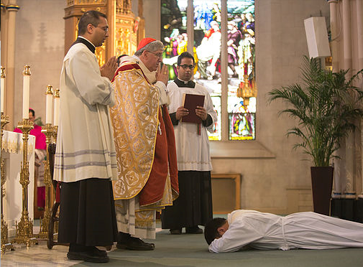
World Day of prayer for Vocation
"The Lamb will be their shepherd and he will guide them to springs of the water of life." Revelation 7.9 14b-17
There is such a need for religious vocations in the church that the Holy Father has set this Sunday aside as a world day of prayer that the Lord of the harvest may send laborers into his harvest. We all have a mission in life, because the word of God, which came to birth in our souls at baptism, is waiting to blossom forth in a more total way in each of us. God has created us for some definite service. While we may not be able to gauge with any real accuracy the effectiveness of our lives, there is nowhere we walk in life without leaving the imprint of who we are upon the ground we tread. We can be a little bit of Christ in our own homes and do our best to co-operate with his invitation to 'come, follow me.'
The gospel picks up the idea of Christ the good shepherd calling each of us by name as we journey through life by different ways. Youth is a time of great generosity, idealism and hope. Evidence of this is in the way young people give of their time and talents to deprived groups in society. In these loud and frantic days it may be more difficult for them to hear the voice of the Lord calling, so we should pray that, as they face the decision about their future role in life, they will leave open the possibility of a religious vocation and ask God's help to make the right choice in their calling. There are enormous riches within the hearts of youth - riches that are theirs to spend lavishly during life. Many of them are unaware of their giftedness and never draw on their talents because they are afraid to take the risk of faith which is needed. By opening their hearts in prayerful service, God, and not material things, will be the focus of their attention. The special calling facing them is to be Christ to others in times of need, to be healers in times of sorrow, towers of strength in times of distress and shoulder to lean upon when support is needed.
It is always easier to wash one's hand of the responsibility of proclaiming the gospel than to become involved. However, the duty of fostering vocations is the concern of the whole believing community and we discharge that responsibility by living full Christian lives. Parents, vocations come from families like your own, where there is a climate created within the home based on solid Christian values, and where encouragement is given to follow the Lord in a special way.

"The ShareLife campaign provides for the needs of our social service agencies, helps our brothers and sisters in Christ across the world, and supports the education of our clergy. It is important that we continue to support the ShareLife appeal, to provide for the needs of the marginalized both here in our communities and around the world. Regardless of their religious beliefs or personal background, ShareLife agencies meet people where there are, treating them with the dignity and respect we all deserve." -
Thomas Cardinal Collins, Archbishop of Toronto.
Today is ShareLife Sunday -
April 17, 2016
Thank you for your generosity.
You can work wonders!

The 2016 ShareLife Parish Campaign Goal:
$12.95 million (225 parishes)
1st Collection Total $13,850.00
2nd Collection April 17th
3rd Collection May 29th
Our Goal is $45,000.00
Next Catholic Women's League meeting will be on Monday April 18th at 7:00 p.m.. Visitors and new members are most welcome.

Year of Mercy with Pope Francis
The thief who went astray in his life, but now repents, clings to the crucified Jesus and begs him: "Remember me, when you come into your kingdom" (Lk 23:42).
Jesus promises to him: "Today you will be with me in paradise." (v43), in his kingdom. Jesus speaks only a word of forgiveness, Not of condemnation; whenever anyone finds the courage to ask for this forgiveness, the Lord does not let such a petition go unheard.
Homily, Nov 24, 2013 - Pope Francis
Vocations - 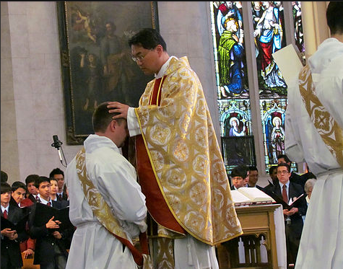
On this Good Shepherd Sunday we celebrate the World Day of Prayer for Vocations. Pray for an increase in vocations to the priesthood, diaconate and religious life, especially for our diocese that God will raise up good shepherds in our midst. If you think God is calling you to be a priest, religious or deacon, contact Fr. Chris Lemieux, Vocation Director, Archdiocese of Toronto
416-968-0997
www.vocationstoronto.ca

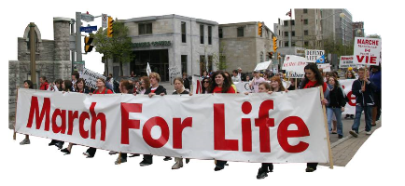

This year Canada's largest pro-life event, the National March for Life in Ottawa is on Thursday May 12.
The theme for this year's march is #END THE KILLING. With the upcoming euthanasia legislature which is designed to legalize the killing of the vulnerable aged, informed, emotionally disturbed and unwanted persons, there has never been a more important time to tell the government to END THE KILLING.
Your presence in Ottawa on May 12 will make a significant impact by making a public statement the LIFE is the first human right!
Bus will leave:
Sts Peter and Paul Church at 6:30am.
There will be a Mass at 6:00 am.
For more information please contact:
Clare at 905-625-7213 or clare@thehansfords.com
_________________________________________
Regarding the introduction of federal Euthanasia / Assisted Suicide legislature please read the insert of the letter by the Archbishop of Toronto - Thomas Cardinal Collins.
Additional copies are available at the back of the church.
Mass | Intentions
Mon Apr 18 | No Mass | Req. by
Tue Apr 19
9:00 am
Wed Apr 20
9:00 am | †Philomena Braganza | Dolly Braganza
7:00 pm | †Giuseppe Catinella (1st Ann.) †Mary Cormier | Family  Tettman Fam
Thu Apr 21 | St. Anselm, Bishop and Doctor of the Church
9:00 am | Int John Dawson | Francis Dudley
Fri Apr 22
9:00 am | †Frank D'Amelio | Anna Colantonio
7:00 pm | †Capone Ferrucio (1st Ann) Int Alan Mukaszkowski | E. Capone
Sat Apr 23 | St. George, martyr
9:00 am | Int Alan Mukaszkowski
4:30 pm | Pro Populo
Sun Apr 24 | Fifth Sunday of Easter
9:00 am | †Joseph Gove  †John Zarb | C. Gove  Pereira Fam.
11:00 am | Int Alan Mukaszkowski
To request a Mass :
simply phone the office and write all the particulars on an envelope and deposit separate from your weekly envelopes into the collection basket. Thank you.

Pray for the sick of the parish, especially for:
Donna Wilson, Jane Murnaghan, Mary Bergin,
Gladys Smyth, Mary Pennell, Anne English, Anita Bergin, Viola McLaughlin, Ada Ottolino, Fred Micallef, Susie Zahra, Marcelle Caruana, Arduino Bonora, Maria Vella, Joan Campbell.
Mission Prayer for the Month of April
African Christians
That Christians in Africa may bear witness of love and faith in Jesus Christ amid political-religious conflicts.
God, Love and Creator, living presence in our world. Today, I have chosen to be united in your love and to go towards my brothers and sisters who are hurt and vulnerable.
Open my eyes and my heart to the sufferings of this world and grant me the ability to experience compassion in truth.
Risen Christ, Light of the world, enlighten the path that leads me towards my poorest brothers and sisters.
Grant me the grace to proclaim and experience the joy of the Gospel.
And by being attentive to the Spirit, Lord, help me to discern your presence and to be a faithful witness of your Holy Name. Amen.

